Poison Safety

- Keep all medicines and household cleaning products in a locked area and out of reach of children.
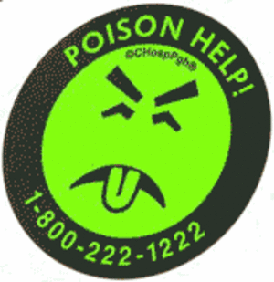
- Throw away medicine that is no longer being used, old or outdated.
- Keep plants out of a child’s reach to avoid accidental ingestion.
- In the event of a poisoning, remain calm and call Poison Control at 1-800-222-1222.
Top 10 Poison Exposures
for Children under Age 5
1. Cosmetics and Personal Care Products
2. Household Cleaning Products
3. Small Toys and Loose Objects
4. Topical Preparations
(creams, gels, and lotions)
5. Analgesics (pain relievers)
6. Plants
7. Cold and Cough Medications
8. Arts/Crafts/Office Supplies
9. Vitamins
10. Pesticides
Treatment Tips
for Your Child
- If the poison was swallowed:
  - Do not give child any food or water.
  - Do not induce vomiting.
- If the poison was inhaled:
  - Move child to fresh air.
- If the poison was on their skin:
  - Rinse area with water for 10 minutes.
- If the poison got in their eye:
  - Flush eye with water for 15 minutes.

This Family Education Sheet is available in Spanish.

