A Safe Ride: Guidelines for Use of Child Car Seats

Motor vehicle injuries are a leading cause of death for children in the United States, according to the Centers for Disease Control and Prevention. Proper use of car seats and seat belts lower serious and fatal injuries by more than 50 percent.

Massachusetts Child Passenger Safety Law

The Massachusetts Child Passenger Safety Law requires children to ride in a federally-approved child passenger restraint — a car seat, booster seat, or seat belt — that is properly fastened and secured until they are 8-years-old or 4 feet 9 inches tall.

Car Seats for Your Child’s Age, Weight, and Height

Infants
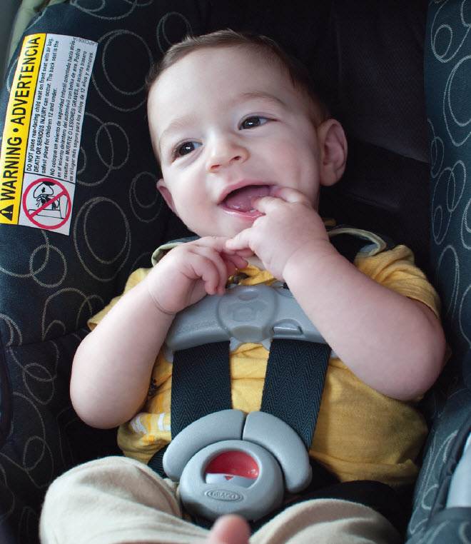
Infants must sit in a rear-facing car seat in the back seat of the car until they are 2-years-old or until they reach the maximum height and weight limit suggested by the car seat maker.
Follow these guidelines for rear-facing car seats:
- Secure the harness straps at or below the shoulders.
- Secure the harness clip across the child’s chest at armpit level.
- Make sure the harness straps are snug; only one finger should fit under the harness strap at the collarbone.
- Never place an infant seat in the front passenger seat because in the event of a car crash, an air bag could severely injure or kill an infant.

Toddlers
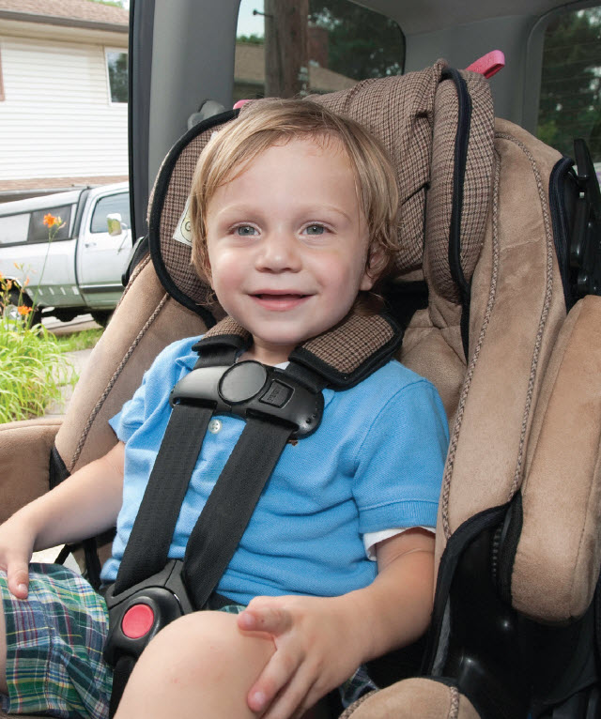
A toddler may be moved into a forward-facing car seat in the back seat of the car when he or she is 2-years-old or has reached the maximum height and weight limit of the rear-facing car seat.
Follow these guidelines for forward-facing car seats:
- Forward-facing car seats must be in the upright position.
- Secure the harness straps at or above the child’s shoulders.
- Secure the harness clip across the child’s chest at armpit level.
- The harness straps must be snug; only one finger should fit under the harness strap at the collarbone.

Booster Seats
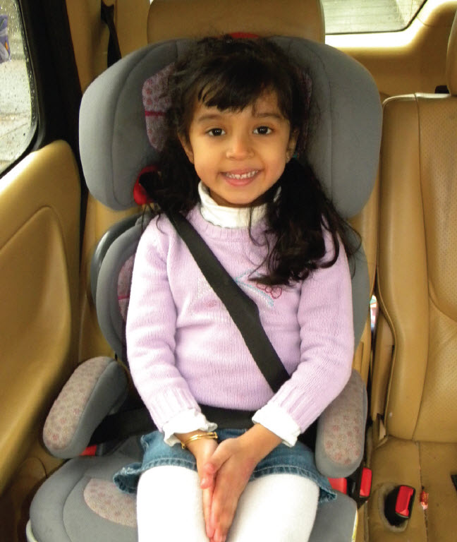
Booster seats help a seat belt fit your child properly. They are often used for children between the ages of 4- and 8-years-old.
All children who can no longer sit in a front-facing car seat must be in a booster seat in the back seat of the car until they are
8-years-old or 4 feet 9 inches tall.

Children must use a lap and shoulder belt while riding in a booster seat.

Follow these guidelines for booster seats:
- Place the shoulder belt across the child’s shoulder, not the neck.
- Place the lap belt across the hips, not the stomach.

Special Needs Car Seats
Special needs car seats are available for your child. Car beds are designed for infants who must travel lying down for medical reasons. If you feel your child may need a special needs car seat, you should talk with your primary care physician/pediatrician.

About Car Seats
Car seats should only be used for six years from the date of creation. The date of manufacture, model number and type can be found on a label on the car seat.

Car seats often come with registration cards. Parents should mail in their car seat registration card, and also register their car seat online in case it is recalled.

How to Install a Car Seat
Car seats should be installed using the Lower Anchors and Tethers for Children (LATCH) Restraint System, or your vehicle’s seat belts. Vehicles manufactured after September 2002 have at least two rear-seat LATCH anchors. Refer to your vehicle’s manual to find their locations.

For more information on where you can get your car seat installed, contact Boston Children’s Car Seat Program at:
- 617-355-7332
- injurypreventionprogram@childrens.harvard.edu
- bostonchildrens.org/injury

A Spanish, Arabic and Portuguese version of this education sheet is available from your provider.

